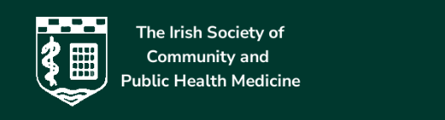

IRISH SOCIETY OF COMMUNITY AND PUBLIC HEALTH MEDICINE

South Leinster Branch

Dear Colleagues,

The South Leinster Branch of The Irish Society of Community and Public Health Medicine is delighted to invite Medical Doctors working in Community and Public Health Medicine and doctors working with children in primary care to the:
Leinster Branch Scientific Meeting of the Irish Society of Community and Public Health Medicine
On
Wednesday, 13th May 2026
10:00 am – 4:00 pm
At
Woodford Dolmen Hotel, Kilkenny Road, Mortarstown Upper, Carlow,
R93 N207

Accreditation for this meeting is pending.

Programme at Glance

9:30am Registration, coffee

10:30am to 11:15am
Psychology services overview

11:15am to 11:30am
Coffee

11:30am- 12:15pm
Dr Michaela Alim Consultant Paediatrician with a special interest in allergy and Honorary Clinical Lecturer in UCC.
“Penicillin Allergy in Children: Risk Stratification and Safe De-labelling in Clinical Practice”,
12:15pm to 1pm
Ashling Sheehan Boyle and Karen Dunne. Technological University of the Shannon.
Play Therapy.

1pm to 2pm Lunch
2:00pm to 2:45pm
Dr Lina Salih.
Work up of child with delayed walking.

3pm to 3:45pm
Ashling Greed OT and Tara Kavanagh OT
Dyspraxia.
4:00 event closure

