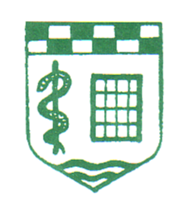
IRISH SOCIETY OF
COMMUNITY AND PUBLIC HEALTH MEDICINE

South Leinster Branch Study Day

Wednesday 13th May 2026
Woodford Dolmen Hotel, Kilkenny Road, Carlow. R93 N207

Please e-mail registration form to Kirsten.fuller@hse.ie or Brendan.hennessy@hse.ie .................................and pay online or pay on the day in cash. (details below)

1.Complete form in white areas
2.Click on File
3.Click on Save & Send
4.Select Send as an Attachment
5.Email to brendan.hennessy@hse.ie......or Kirsten.fuller@hse.ie ............................................................
Name: | Dr
MCRN:
Address:
Telephone number:
Email address:
Dietary requirements:
area of work | X
Community Medicine
Public Health
Retired
After submitting your registration form please pay on-line:
Fee: € 90

Payee name: Irish Society of Community and Public Health Doctors
IBAN: IE98 AIBK 9344 0216 4690 78
BIC: AIBKIE2D

Reference: Your name and medical council registration number.
(This is essential for matching your payment to your registration form)

If you require an alternative payment option please email …………………………………………………………..
A receipt of payment will be emailed with CPD certs following the meeting.

