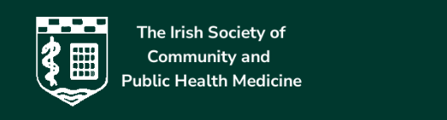

IRISH SOCIETY OF COMMUNITY AND PUBLIC HEALTH MEDICINE
MUNSTER BRANCH

Dear Colleagues,

The Munster Branch of The Irish Society of Community and Public Health Medicine is delighted to invite Medical Doctors working in Community and Public Health Medicine, doctors working with children in primary care to the:

Munster Branch Scientific Meeting of the Irish Society of Community and Public Health Medicine
on
Wednesday, 6th May 2026
9:00 am – 4:00 pm
at
Dunraven Arms Hotel, Adare, Co. Limerick, V94 KV2P

This event has been accredited for 7 CPD points

