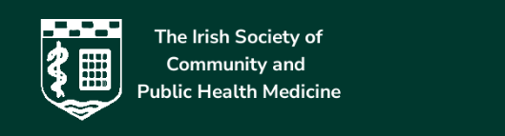

PROGRAMME

Munster Branch Scientific Meeting of the Irish Society of Community and Public Health Medicine
Dunraven Arms Hotel, Adare, Co. Limerick, V94 KV2P
6th May 2026

9-9:30 Registration, coffee
9:30- 11:15 scientific programme
9:30 | Dr Siobhan Neville, Consultant Paediatrician UHL - Paediatric Inclusion Health, Associate Professor of Paediatrics at UL: Social Inclusion and healthcare for children on the margins
10:05 | Prof Tara Connelly Consultant Surgeon UHL special interest in Paediatric Surgery: Common paediatric surgical conditions presentations and management
10:40 | Dr Sarah Kilroy and Dr Christine O’Connell Psychologists Primary Care Child and Family Psychology Service St Camillus’s Campus: “An attachment-informed approach to supporting childern’s emotional and behavioural development.
11:15- 11:30 coffee
11:30- 1:00 scientific programme
11:30 | Dr Siobhan Gallagher Consultant Paediatrician UHL - Community Paediatrics: Early identification of motor disability
12:15 | Lillian Edwards and Elaine Hannan Physiotherapist St Gabriels Disability Network Team Limerick: Gross Motor Function Classification (GMFC) of Cerebral Palsy and the Hammersmith Infant Neurological Examination (HINE).
1:00- 2:00 lunch
2:00-3:50 scientific programme

2:00 | Aoife McGuire Senior Speech and Language Therapist Barrack View Primary Care Centre: Developmental Language Disorder (DLD),Speech Sound Disorders (SSD) and Stammering an overview of SLT profiling and management in childhood.
2:35 | Prof Billy O`Connell Foundation Professor and Chair of Physiology, and Head of Teaching and Research in Physiology at the University of Limerick School of Medicine: This presentation will explore how the human brain, particularly, the differences between the left and right hemispheres, shapes perception, understanding and culture. It will outline the brain’s basic structure and scale, highlighting its vast number of neurons and synapses. Through visual examples, it will show how the right hemisphere perceives a meaningful, unified whole (GESTALT), while the left hemisphere focuses on analysis, and breaks things into parts. The talk will encourage self-reflection and an openness to the new and warns that repetition can create the illusion of truth which leads us astray. It will emphasise that understanding depends on interpretation, not on events alone, and shows how mindset, education and skills shape how we understand the world.
3:10 | Mr Peter Staunton Paediatric and Adult Orthopaedic Surgeon with a specialist interest in paediatric orthopaedics: Developmental Dysplasia Hip (DDH)

4:00 event closure

